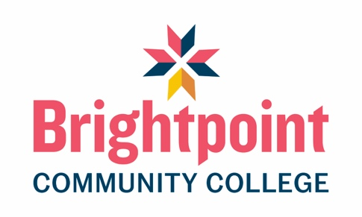

Distance Learning Completion Requirements for the Funeral Service Program
Most classes in the Funeral Service Program can be completed through distance learning; however, a few important stipulations apply. Please review the information below carefully:
- All Funeral Services Core lecture classes require students to attend weekly scheduled Zoom lectures (except FNS 125 - Microbiology for Funeral Services – which is a fully virtual class).
- All students enrolled in the Funeral Services program are required to have reliable internet access.
- All students enrolled in the Funeral Services program are required to have a camera and microphone available during Zoom lecture sessions to be able to communicate with classmates and the instructor.
- All students enrolled in the Funeral Services program will be required to attend four (4) scheduled on-campus activities when enrolled in FNS 214 – Restorative Art Technical Applications.
- All students enrolled in the Funeral Services program will be required to complete at least ten (10) embalmings while enrolled in FNS 113 & 114 – Embalming Laboratory I & II. All Funeral Service students will also be required to attend one (1) on-campus Embalming Laboratory activity for Embalming Certification purposes.
- All students enrolled in the Funeral Services program will be required to participate and document at least five (5) First Call activities; including receiving notification of death and transfer of decedent from place of death.
- All students enrolled in the Funeral Services program will be required to document participation or observation of at least five (5) Funeral Arrangement Conferences prior to program completion.
- All students enrolled in the Funeral Services program will be require to document participation or observation of at least five (5) Funeral Services prior to program completion.

