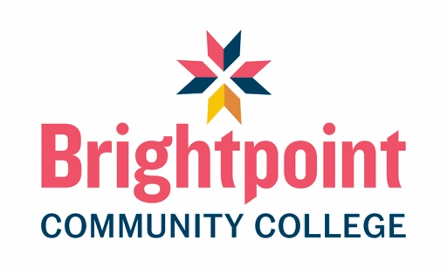

FUNERAL SERVICE PROGRAM LABORATORY AND FUNERAL DIRECTING ACTIVITY REQUIREMENTS
Students enrolled in the Funeral Services Program must complete all the following Laboratory experiences and Funeral Directing activities prior to program completion. These requirements are fulfilled through enrollment in designated program courses that include the associated activities, and documentation of all completed Laboratory experiences and Funeral Directing activities must be maintained as evidence of program completion.

Embalming Laboratory Requirements:
- Students must complete these requirements while enrolled in FNS 113 – Embalming Laboratory I and FNS 114 – Embalming Laboratory II.
- Students must actively participate in a minimum of ten (10) embalmings while enrolled in FNS 113 and FNS 114. These requirements may be completed through:
a. Participation in scheduled on-campus embalming laboratory activities; or
b. Participation at an approved funeral home (see Off-Campus Site Requirements), provided the student is employed by the funeral home and enrolled in FNS 113 and FNS 114.
- Students must actively participate in at least one (1) on-campus embalming-related activity to satisfy certification requirements.
- All embalming laboratory activities must be appropriately documented and verified in accordance with program requirements.

Restorative Art Technical Applications Requirements
- Students must complete all hands-on activities while enrolled in FNS 214 – Restorative Art Technical Applications.
- Students are required to attend four (4) scheduled on-campus sessions in addition to participating in weekly Zoom sessions.
- Students must complete and submit all required projects for FNS 214 during the final scheduled on-campus session.
- All required activities and projects must be completed and documented in accordance with program requirements.

Funeral Directing Specific Requirements
- Students must complete the Funeral Directing requirements while enrolled in FNS 231 – Funeral Service Management I, FNS 232 – Funeral Service Management II, and FNS 290 – Coordinated Internship.
- Prior to graduation, students must document participation in:
  - A minimum of five (5) First Call activities;
  - Observation of or participation in a minimum of five (5) funeral arrangement conferences; and
  - Observation of or participation in a minimum of five (5) funeral services.
- Funeral directing activities may be completed in either a funeral home or classroom setting.
a. Students employed by or affiliated with a funeral home may complete these requirements at an approved funeral home, subject to program approval (see Off-Campus Site Requirements).
b. Students who are not affiliated with a funeral home will receive assistance from Funeral Service Program Director or faculty in securing an approved funeral home placement to complete these requirements.
- All funeral directing activities must be appropriately documented and verified in accordance with program requirements.

Off-Campus Site Requirements
An approved off-campus site is defined as a Funeral Home or facility at which a student can complete embalming requirements as required by FNS 113 & 114 - Embalming Laboratory I & II, and Funeral Directing requirements as required by FNS 290 – Coordinated Internship and has completed the following requirements:
  - Is a licensed as a Funeral Establishment in the State they are in (verification of licensure will be acquired by Funeral Services Program prior to approval).
  - Completed a signed Affiliation Agreement between the Funeral Home and the College.
  - Has completed an on-site visit (physical or virtual) by the Funeral Services Program Director or designated faculty or college staff member.
  - A designated member of the Funeral Home staff (licensed as a Funeral Service professional in the State they are practicing in) has completed preceptor training and has completed the preceptor training verification form and preceptor agreement.
  - Provided a copy of the latest formaldehyde testing results for Embalming Activities.
  - Provided a copy of the General Price List for the Funeral Home for Funeral Directing activities.
Approval of an off-campus site is contingent upon satisfaction of all applicable requirements and verification by the Funeral Services Program.

