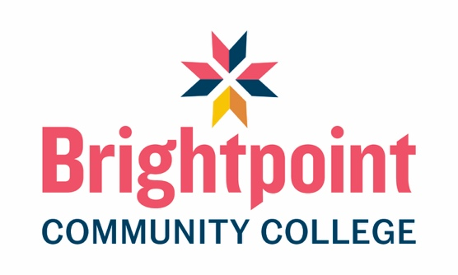

Program Accreditation
The American Board of Funeral Service Education (ABFSE) serves as the national academic accreditation agency for college and university programs in Funeral Service and Funeral Services Education. ABFSE is the sole accrediting agency recognized by the U.S. Department of Education and the Council on Higher Education Accreditation in this field.
The Funeral Services degree program at Brightpoint Community College is accredited by the American Board of Funeral Service Education (ABFSE). Location: 992 Mantua Pike, Suite 108, Woodbury Heights, NJ 08097. Contact: (816) 233-3747.

