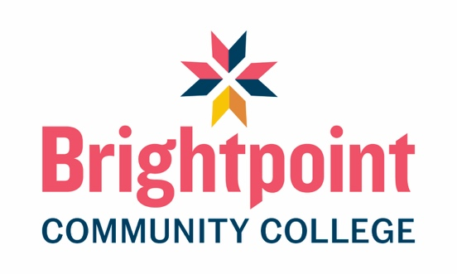

Graduation Requirements

Students must complete a minimum of 63 credit hours for the AAS degree with a grade of “C” or higher in all program courses. In addition, students must have a GPA of 2.0 to be eligible for graduation.

State Licensure
Graduating from Brightpoint’s Funeral Services Program allows students to take the National Board Exams. After passing the National Board Exam for Arts and Sciences, students will also be required to complete a 2,000-hour internship and pass the Virginia State Board Exam to fulfill the requirements for the Virginia Board of Funeral Directors and Embalmers and become licensed in Virginia.
All states require funeral directors and embalmers to be licensed. Licensing requirements vary by state, but most require applicants to complete at least two years of formal education in a Funeral Services or Mortuary Science program accredited by the ABFSE, serve an internship, and pass both the National Board Exams and a state level qualifying exam. Requirements for professional reciprocity also vary by state. Students interested in a career in funeral service in a state other than Virginia should contact that state’s licensing board for specific requirements.

Acceptance into, continuation in, and graduation from the Brightpoint Community College Funeral Services program does not guarantee employment within a funeral home/mortuary or other related practice associated with funeral service.

