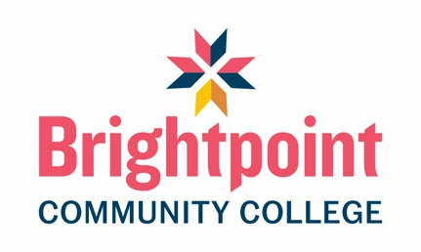

Funeral Services: Program Data and Statistics

Contact Information
Address:
13101 Route 1
Chester, VA 23831

Program Director: Richard Sikon
Phone: (804) 706-5066
Email: rsikon@brightpoint.edu
FAX: (804) 768-6624
Website: Funeral Services, AAS

Accredited degree offered: Associate in applied science (AAS)
Distance education: Yes
Part-time option available: Yes

Funeral Services Program Data
Year | Total enrolled | # of New Students | # of Grads | Timely Grad* | Graduation Rate** | Did not finish*** | Overall % Employed | Employed  In FS
2025 | 96 | 53 | 45 | 44/45 | 97% | 2 | 98% | 87%
2024 | 90 | 58 | 52 | 51/52 | 89% | 5 | 100% | 87%
2023 | 89 | 41 | 33 | 33/33 | 85% | 1 | 91% | 82%

*Timely graduation = complete program in 1½ times designated program length.
**Graduation rate reflects cohort graduation rate (% of students from original cohort completing in the designated year)
***Left before completing the program; did not finish.

National Board Statistics

Sciences | Takers | School Pass Rates | National Pass Rates
2025 | 33 | 73% | 79%
2024 | 30 | 73% | 73%
2023 | 25 | 76% | 69%

Arts | Takers | School Pass Rates | National Pass Rates
2025 | 38 | 82% | 78%
2024 | 33 | 76% | 78%
2023 | 25 | 96% | 78%

School pass rate is based on first-time test takers within one year of graduation.

Contact the program directly for information regarding success of Distance Education graduates.

