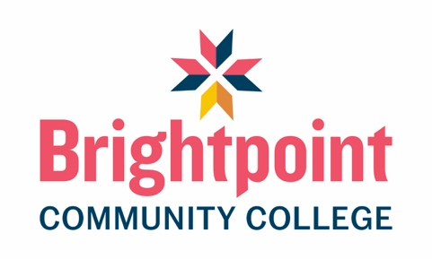

Program Aims, Objectives, and Outcomes
The Funeral Services Program is designed to give students the fundamental knowledge and skills needed to acquire entry-level positions in the funeral service profession. The Program’s central aim is to recognize the importance of funeral service personnel as members of a human services profession, as members of the community in which they serve, as participants in the relationship between bereaved families and those engaged in the funeral service profession, as professionals knowledgeable of and compliant with federal, state, provincial/territorial, and local regulatory guidelines in the geographic area where they practice, as well as professionals sensitive to the responsibility for public health, safety, and welfare in caring for human remains (ABFSE, Accreditation Manual).
The Mortuary Science concentration prepares students to become licensed as both a Funeral Director and Embalmer. Students who do not wish to pursue licensure as an Embalmer shoulder consider the Funeral Director concentration.

Program Objectives
The objectives of the Funeral Services Program are:
- Expand knowledge and understanding about the funeral service profession.
- Educate students in every phase of funeral service and enable them to develop proficiency and skills necessary for the profession.
- Educate students concerning the responsibilities of the funeral service profession to the community at large.
- Emphasize high standards of ethical conduct.
- Provide a curriculum at the post-secondary level of instruction.
- Encourage student and faculty research in the field of funeral services.

Program Outcomes
By the completion of this program, students will be expected to demonstrate an intermediate level of competency in the following skills:
- Explain the importance of funeral service professionals developing relationships with the families and communities they serve.
- Identify standards of ethical conduct in funeral service practice.
- Interpret applications of federal, state, and local laws to ensure compliance.
- Apply principles of public health and safety in the handling and preparation of human remains.
- Demonstrate technical skills in embalming and restorative art that are necessary for the preparation and handling of human remains.
- Demonstrate skills required for conducting arrangement conferences, visitations, services, and ceremonies.
- Describe the requirements and procedures for burial, cremation, and other accepted forms of final disposition of human remains.
- Describe methods to address the grief-related needs of the bereaved.
- Explain management skills associated with operating a funeral establishment.
- Demonstrate verbal and written communication skills and research skills needed for funeral service practice.

Student Outcomes
In addition to the program outcomes, students will be expected to be demonstrate competency in the following skills:
- Describe the service needs for the pre-need, at-need, and aftercare time frames by evaluating the needs of those who are making funeral arrangements.
- Create and plan activities and ceremonies designed to meet the needs of those who mourn.
- Demonstrate knowledge of funeral and cremation memorialization and merchandise options.
- Conduct an analysis of the human remains to determine the proper current embalming and restorative art procedures.
- Demonstrate knowledge of safety requirements when working in the preparation room.
- List necessary information for death certificates.
- Demonstrate understanding of legal, professional, and ethical issues regarding funeral service.
- Demonstrate the "soft skills" required to be an effective member of the funeral service profession including effective verbal and written communication skills, collegiality, and a professional work ethic and behavior.

